Discover Russia

Russia is the largest country on our dear planet and many tourists from all over the world would like to visit at least a couple of interesting places in our wonderful country.

And so, we tell you about the best places to travel around our vastness!

Undoubtedly the nature of Russia is beautiful everywhere, from the southern subtropical forests, to the northern tundra and during the trip you can find a lot of interesting places, we will leave such unique places to the surprise of future travelers! You can start your journey in Russia literally from anywhere! But in order to marvel at the scale of our country and see the greatest contrast, it is best to choose the Far East and the city of Vladivostok as a starting point. You can learn about the sights of the cities themselves from many sources, but we will tell you what interesting things you can visit directly in these regions.

Far East of Russia:

Route:

**Vladivostok** - This city will give you unforgettable memories if you are a car enthusiast or a lover of vacations at the sea! Here you can swim in the Sea of Japan and admire the view from the local hills!

**Blagoveshchensk** - A unique small town on the border with China. Look at China right from the waterfront! And maybe even visit China to admire Blagoveshchensk from the other shore

**Petropavlovsk-Kamchatsky** - plunge into the wild untouched nature. Visit geysers and volcanoes!

Popular Attractions:

**Kamchatka Volcanoes** - An iconic symbol of the region, offering unique opportunities for exploring nature.

**Aquarium on island “Russkiy”-** A good place to explore the local marine reptiles! The children will be excited.

**Zoos with Amur tiger** – just zoos 😊 Amur tigers are really impressive!

Lesser-known but interesting attractions:

**The border of 3 countries** – A truly unique place, here you can see 2 countries at once in one place! North Korea and China.

**Kuril Islands** - beyond the main tourist routes, these islands offer unique natural landscapes and exploration opportunities.

Siberia:

Route:

**Novosibirsk** - the starting point for your journey through Siberia. This large industrial city is famous for its scientific institutes and rich cultural life. Visit the Novosibirsk Zoo, one of the largest in Russia, and the Novosibirsk State Academic Opera and Ballet Theater.

**Krasnoyarsk** - immerse yourself in the atmosphere of Siberia, a city located on the banks of the mighty Yenisei River.

**Irkutsk and Lake Baikal** - delve into the history and nature of Lake Baikal, the deepest lake on the planet. Irkutsk, known for its wooden architecture, will be the perfect starting point for your exploration of the lake and its surroundings.

Popular Attractions:

**Lake Baikal** - one of the most amazing places in Russia, Baikal offers unique views and opportunities for outdoor activities such as hiking and kayaking.

**Central Reserve** - breathtaking nature and a multitude of animals and plants unique to Siberia.

**Altai Mars** - a stunning beautiful expanse, that's where the immense beauty around you takes your breath away!

Lesser-known but interesting attractions:

**Shaman Stone in Listvyanka** - a sacred place for the local population, where you can learn about the mystical history of Siberia.

**The salt lakes of Khakassia** - a great place for a wellness holiday

Central Russia and the Urals:

Route:

**Moscow** - the capital of Russia and a cultural hub. Take a tour of the Kremlin, visit Red Square, and explore the city's rich history in museums such as the Hermitage and the Pushkin Museum.

**Kazan** – the largest city on bank of Volga river and the capital of republic Tatarstan. Local Kazan’s Kremlin located in Unesco World Heritage.

**Nizhniy Novgorod** – the city, which was build like a fortress, for secure purposes. The city has a local Kremlin too, but it is the impregnable in modern Russia. It was attacked about five times and it stayed indefeated.

**St. Petersburg** - a magnificent city rich in architectural masterpieces and historical landmarks. Spend a day in the Hermitage, stroll through the Peter and Paul Fortress, and enjoy the White Nights of this amazing city.

**Yekaterinburg** - where Europe and Asia meet, known for its historical significance and beautiful nature. Visit places associated with the fate of the Romanovs, such as the Church on the Blood and the Chisty Pond.

**Ufa -** the capital of Bashkortostan, grab some echpochmak and kumys and set out to conquer the mountain rivers.

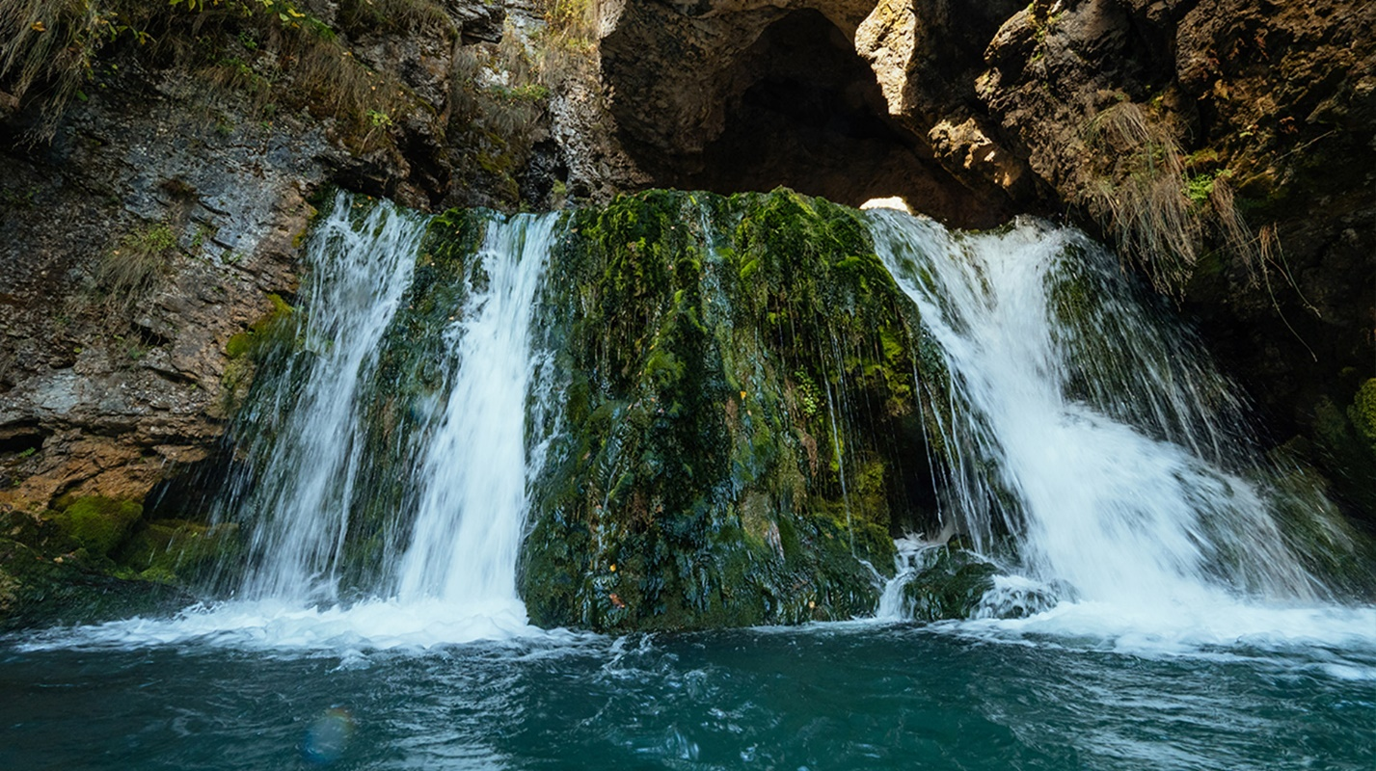

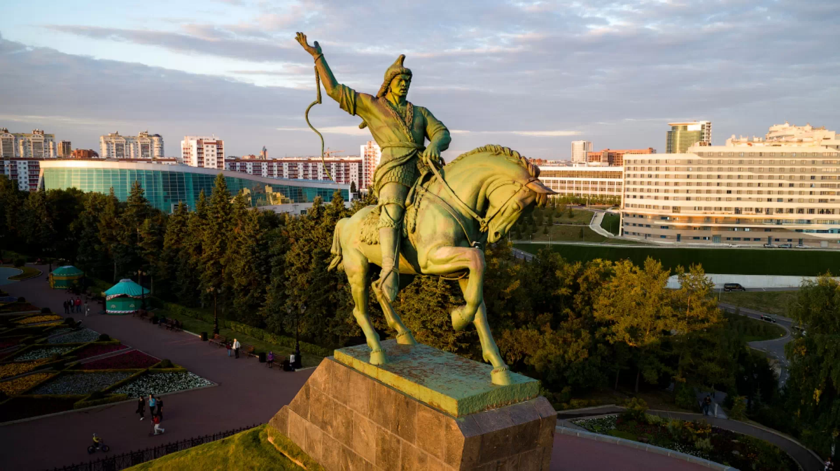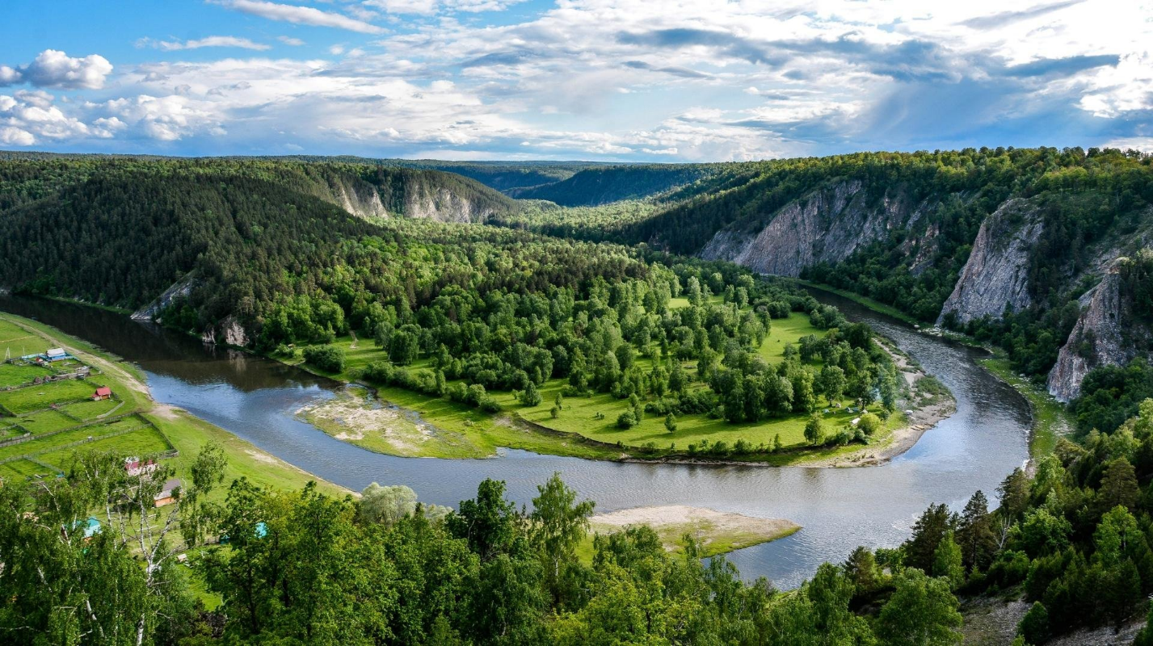

**Chelyabinsk** - the whole world knows about this place in the Urals! Do you know why the Chelyabinsk meteorite has not been seen? - Because it flew from the side of the sun xD

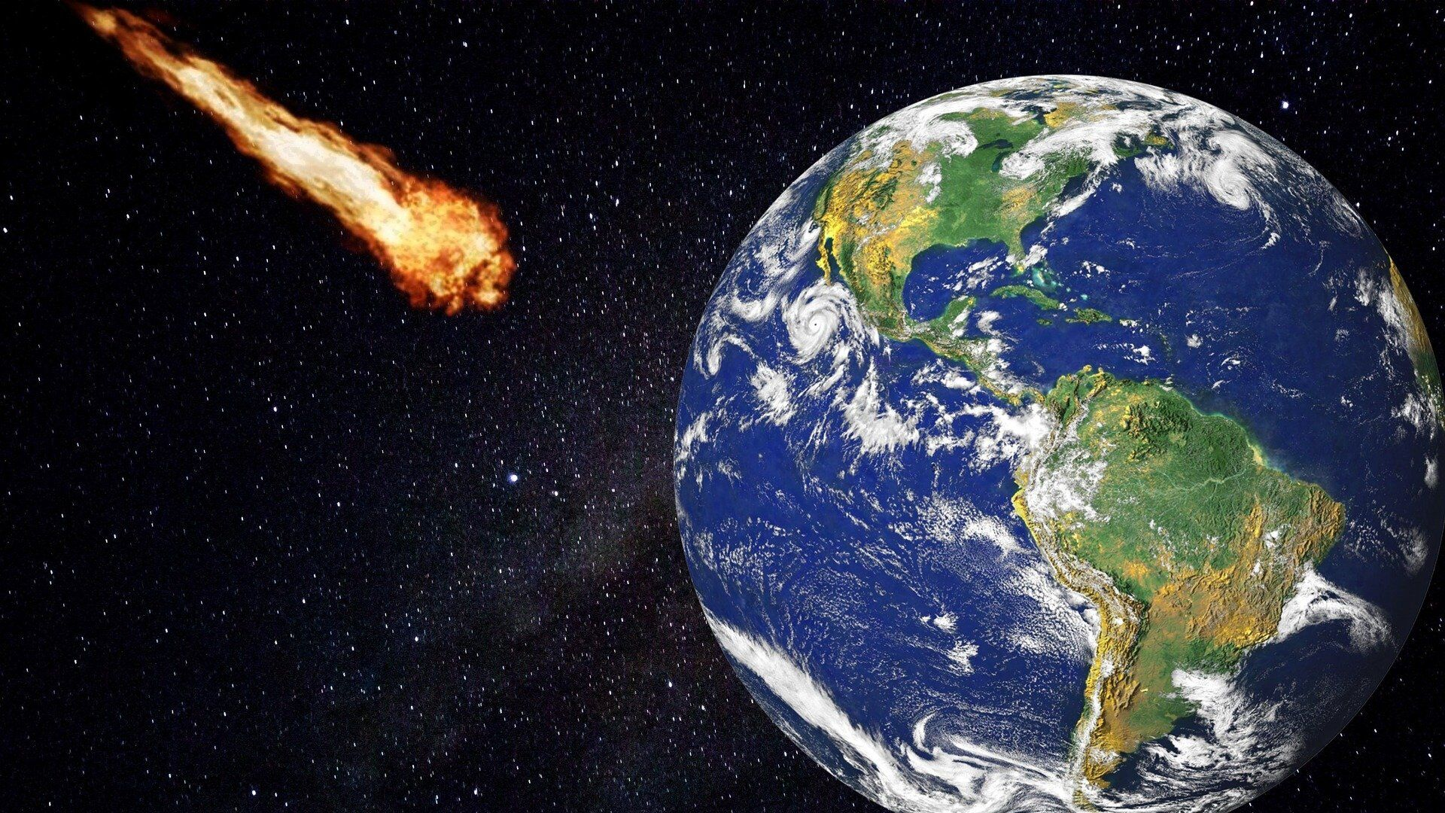

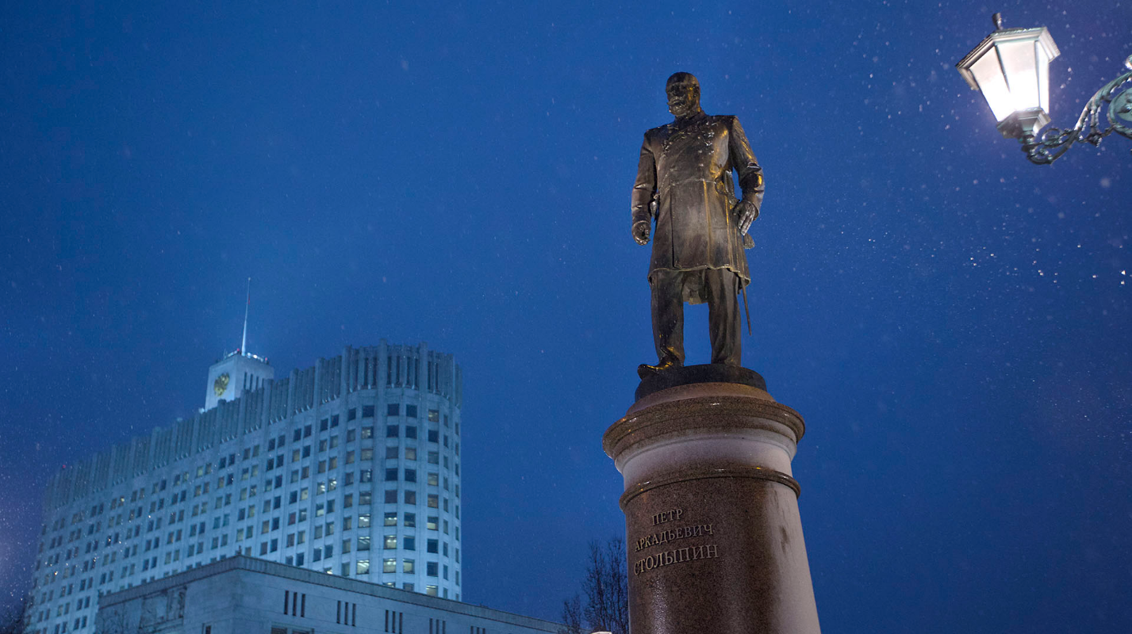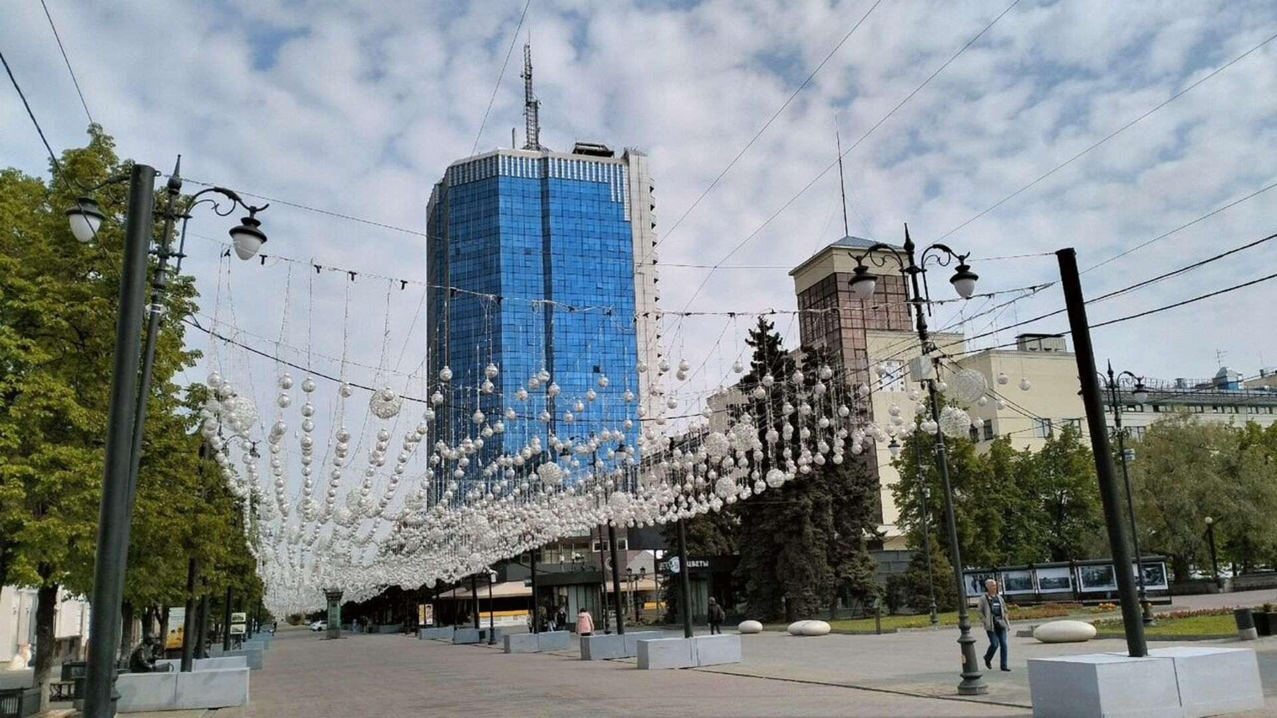

Popular Attractions:

**Hermitage in St. Petersburg** - one of the largest museums in the world, housing rich collections of artworks and antiques.

**Kremlin and Red Square in Moscow** - symbols of Russia, steeped in history and culture.

**Central Park of Culture and Rest in Yekaterinburg** - a perfect place for relaxation and walks in the city center.

Lesser-known but interesting attractions:

**Ski resorts of the Urals, such as "Bannoe" and "Belaya"** - unusual for many tourists, these resorts offer excellent opportunities for winter activities.

**City Museum in St. Petersburg** - a hidden gem offering unique insights into the history of the city and its inhabitants.

**Gadelha Falls –** biggest waterfall in Ural!  
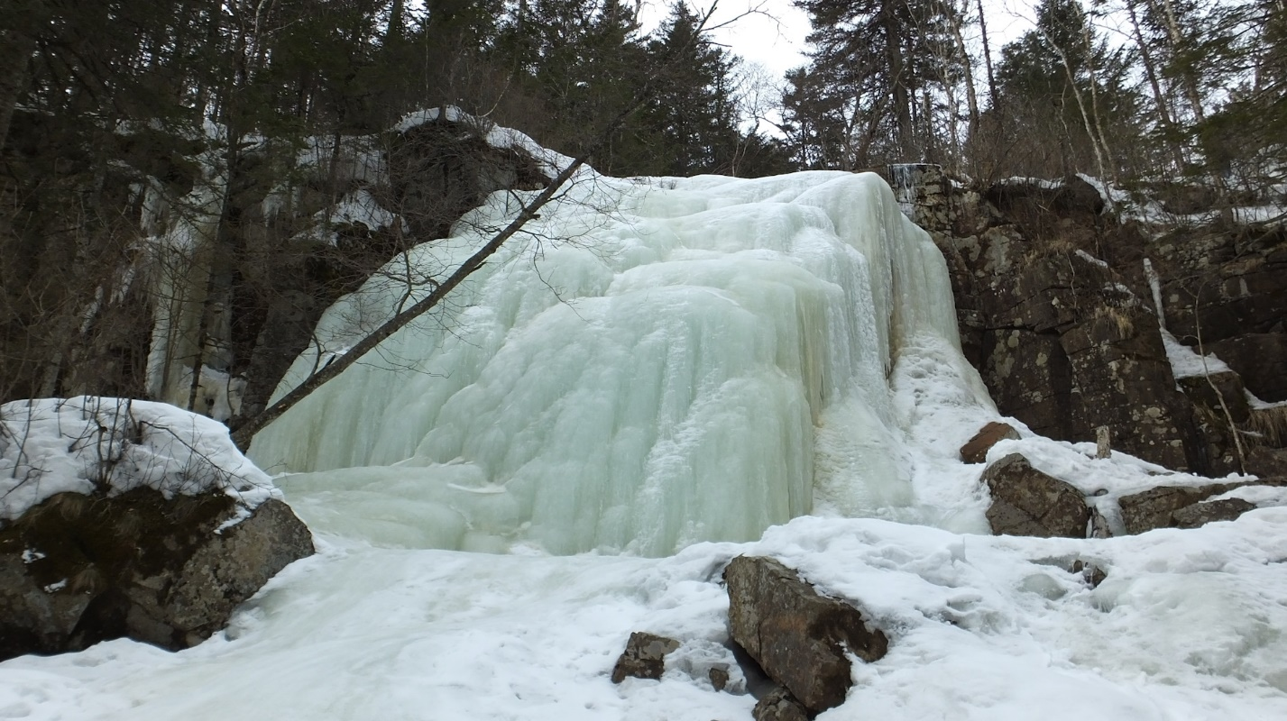

European Part of Russia (Crimea, Moscow, St. Petersburg, Golden Ring):

Route:

**Moscow** - as the starting point of your journey through the European part of Russia, spend time in the Kremlin, Arbat, and city museums such as the Pushkin Museum and the Tretyakov Gallery.

**St. Petersburg** - a magnificent city, rich in architectural masterpieces and historical landmarks. Spend a day in the Hermitage, stroll through the Peter and Paul Fortress, and enjoy the White Nights of this amazing city.

**Crimea** - immerse yourself in the beauty and culture of Crimea by visiting the cities of Sevastopol and Yalta, as well as historical landmarks such as churches and fortresses.

Popular Attractions:

**Peter and Paul Fortress in St. Petersburg** - a symbol of the city, a magnificent fortress that played a key role in the history of Russia.

**Crimean Aquarium in Sevastopol** - an amazing underwater world where you can see a variety of marine animals and plants.

**Red Square in Moscow** - an icon of Russia, embodying the history and culture of the country.

Lesser-known but interesting attractions:

**Arkhangelskoye Estate Park in the Moscow Region** - a beautiful historical park offering the opportunity to enjoy nature and architecture of the Moscow estate.

**Ascension Church in Kolomenskoye** - a cultural heritage site distinguished by its architectural style and historical significance.

Journey through the Northern Territories and Kaliningrad:

Route:

**Murmansk** - start your journey from the northernmost city of Russia. Visit the Museum of the World Ocean to learn about the maritime history of the region and enjoy views of the Kola Bay.

**Kaliningrad** - immerse yourself in the atmosphere of the Baltic coast, exploring island fortresses such as Kronstadt and Fort Krasnaya Gorka, and visiting museums dedicated to the history of the region.

Popular Attractions:

**Museum of the World Ocean in Murmansk** - a unique museum telling the maritime history and expeditions to the Arctic.

**Wrangel Island Reserve in Kaliningrad** - breathtaking nature and many ecological routes for exploring nature.

Lesser-known but interesting attractions:

**Monument to the Forgotten Soldiers in Murmansk** - a symbolic place dedicated to the memory of those who died during the defense of Murmansk during the Great Patriotic War.

**Cathedral in Kaliningrad** - a beautiful example of Gothic architecture, one of the symbols of the city.

**Kavkaz**

**Grozny -** is the capital of the Chechen Republic! A city with a big scope, Grozny-City, huge mosques, just wow!

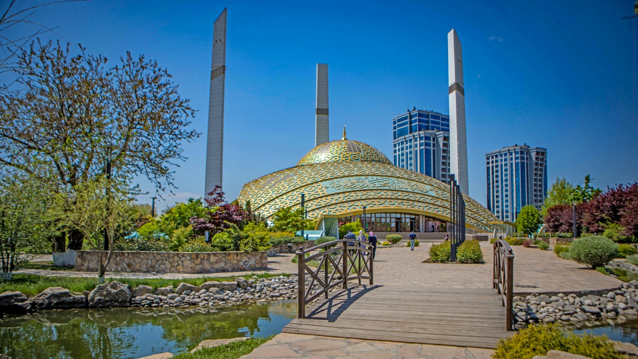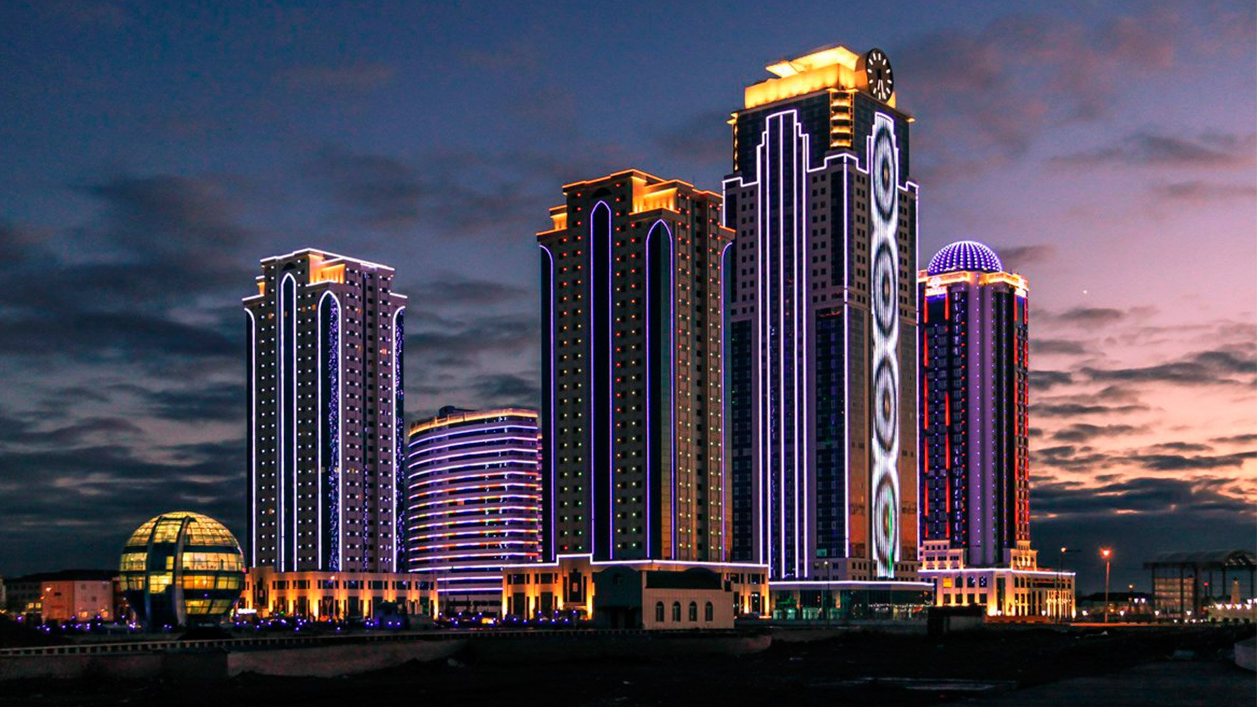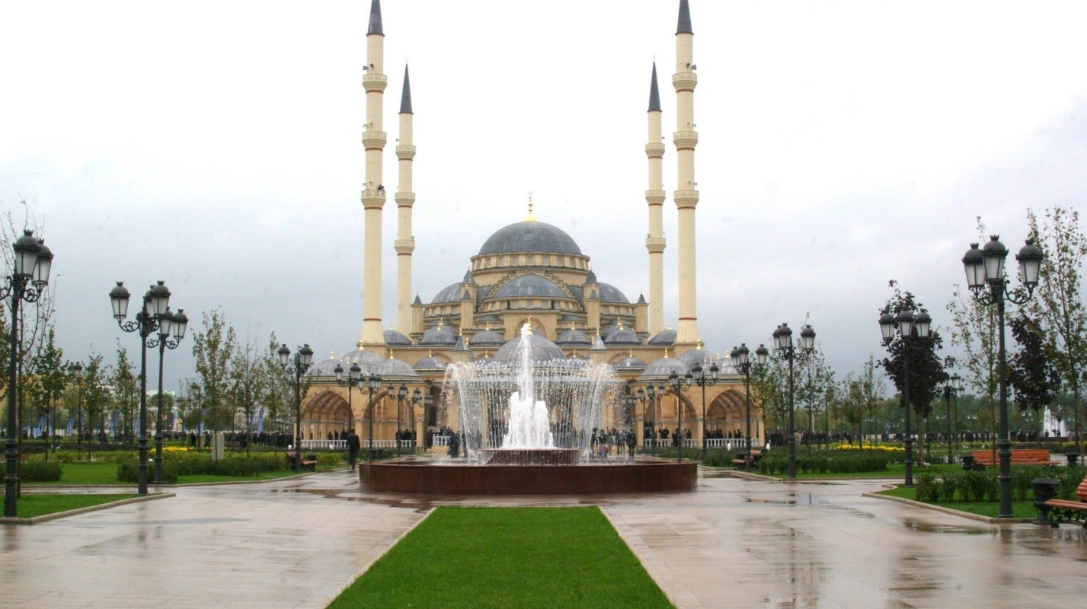

**Essentuki** - a cozy, health-improving town. And in general, I just love Essentuki water.

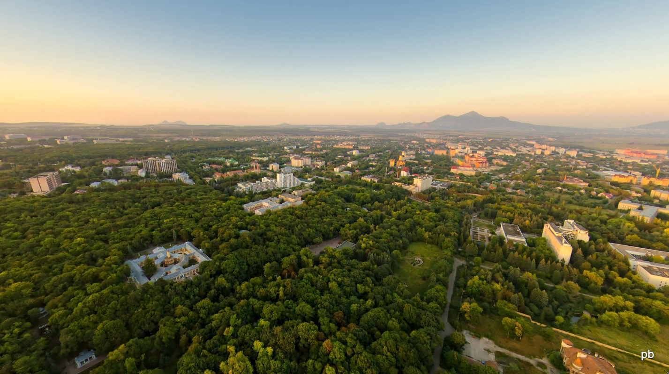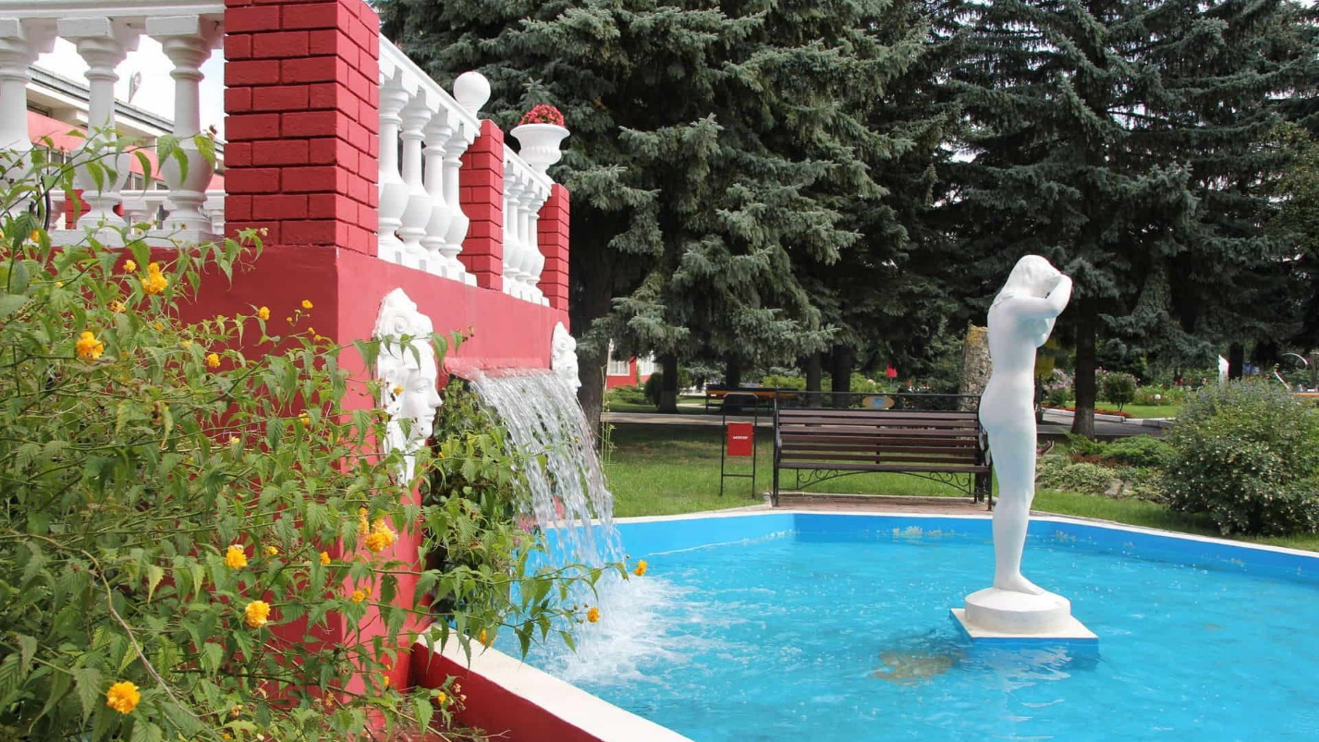

**Makhachkala** - is the largest city in the Caucasus, welcome to Dagestan! Be sure to take a shashlik. This city is famous for its safety.

